56th Melbourne Gang Show (& Cub Sleepover!)
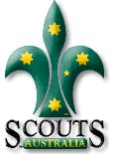
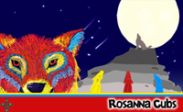

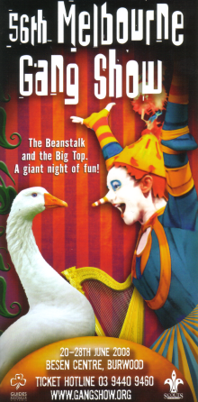
The Scouts and Guides of Victoria present the 56th Melbourne Gang Show, at the Besen Centre, Burwood.

See also: http://www.gangshow.org

Rosanna Cubs (& parents, siblings etc., welcome too!) will attend the 2pm performance on Saturday, 21st of June.

Following the performance, we’ll be coming back to the Hall for a family BBQ, and then the parents and siblings will leave us and the Cubs will have a sleepover in the Hall.

This Year we’re likely to be joining up with 1st Bendigo Cubs, who would come along to our BBQ and Sleepover after Gang Show!

Costs for the performance (bulk discount) are:
- Adults: $18
- Children: $12
- Family BBQ: $5 per person.

➔ We need to get our bookings in for the show as soon as possible, to enable us to get the best possible seats at the performance. Once we’ve put the booking in, you may still be able to buy tickets for the performance, but you’ll be seated elsewhere in the theatre and the ticket prices will be $5 higher due to missing the bulk discount.

Please return the tear off form below – RETURN IT ASAP!. We’ll then get our tickets organised.

Come along and have a ball!

56th Melbourne Gang Show, 2008
We’re coming along….
(1) Family Name:______________________ Cub(s):______________________

(2) TOTAL number of tickets required (including Cubs):
Adults ($18):______________________ = $____

Child ($12): ______________________ = $____

(3) Attending the BBQ? Adults ($5): ______________ + Child ($5): _______________ = $____

Total: = $____
(4) Cub(s) staying for sleepover (Free!) – Name(s): _____________________________

Please bring this slip in ASAP, so we can get our tickets organised!
Please make cheques payable to “Wayne Renfrew”, as I’ll be buying tickets and getting reimbursed

